- Interface a DC Motor, an NO/OFF switch, a RED LED, and a GREEN LED to a PIC16F84A microcontroller using Proteus (20 points)
Show your design here (cop and paste here)
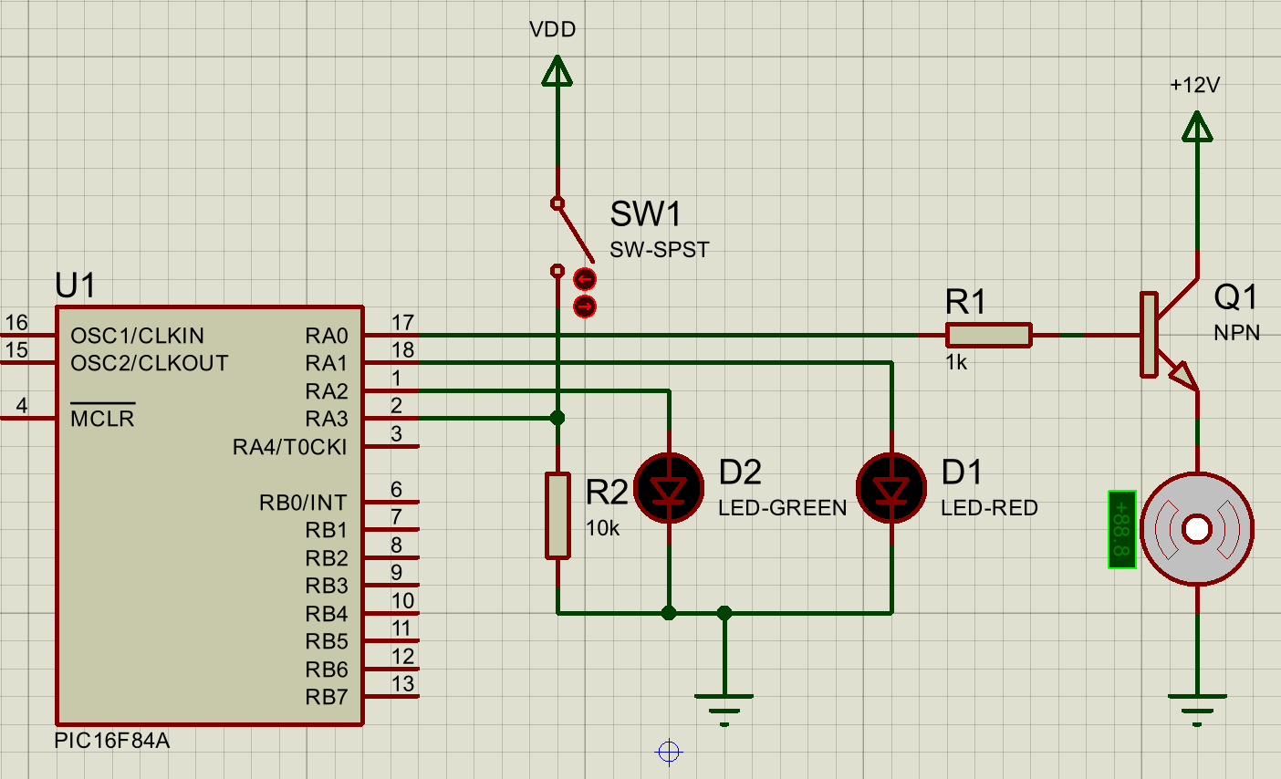

- Write a program such that when the switch is connected, the motor runs and GREEN LED lite. When switch is disconnected, then the motor stops and the RED LED is lite. You need to write the following subroutines: Proteus (30 points)
MOTOR_LEDON: Turn on GREEN LED and Turn off RED LED
BSF PORTA, 2
BCF PORTA, 1
RETURN
MOTOR_LEDOFF: Turn off GREEN LED and Turn on RED LED
BSF PORTA, 1
BCF PORTA, 2
RETURN
MotorON Turn on Motor
BSF PORTA, 0
RETURN
MotorOFF Turn of Motor
BCF PORTA, 0
RETURN
mySwitch to Turn on/off the system based on the above requirements
BTFSS PORTA, 3
CALL MAIN
BTFSC PORTA, 3
CALL MAIN2

- Draw the flowchart for the system Proteus (10 points)
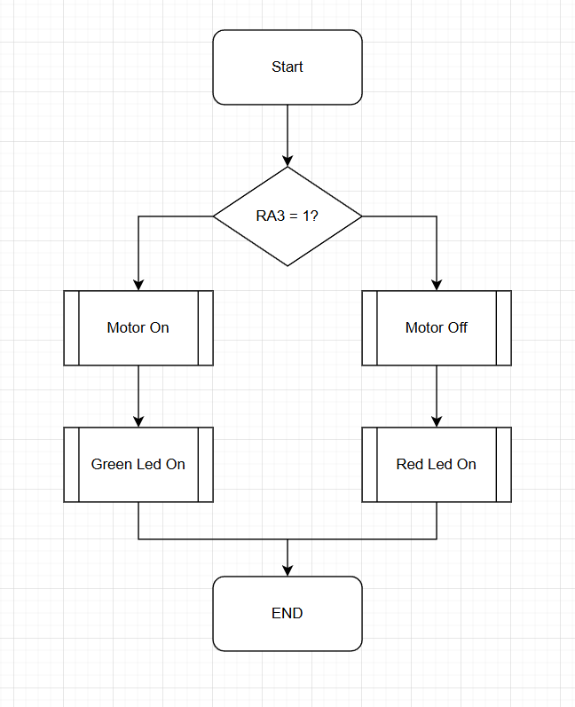
- Develop a video to demonstrate your design (you need to introduce yourself in the video) Proteus (40 points)

